**WEEK 4: Assignment**

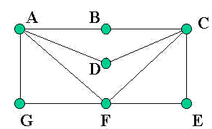

1. Does the above graph have an Euler’s path or cycle? Justify your answer.

Answer: The above graph have an Euler’s path or cycle as ABCDAFCEFG or ABCDAFCEFGA. A Eulerian path is a trail in a graph which visits every edge exactly once. It is also called as Unicursal Graph.

Similarly, an Eulerian circuit or Eulerian cycle or Euler Tour is an Eulerian trail which starts and ends on the same vertex.

Example:



Euler’s path: c-b-a-d-c-e

2.Does the above graph have a Hamiltonian Path and Cycle ? Justify your answer.

Answer: The above graph have a Hamiltonian Path G-F-E-C-B-A-D or G-F-E-C-D-A-B. It is a path in an undirected or directed graph that visits each vertex exactly once. Each vertex is crossed once just like a cycle. The above graph does not have a Hamiltonian Cycle. A Hamiltonian cycle (or Hamiltonian circuit) is a Hamiltonian path that is a cycle. Example:

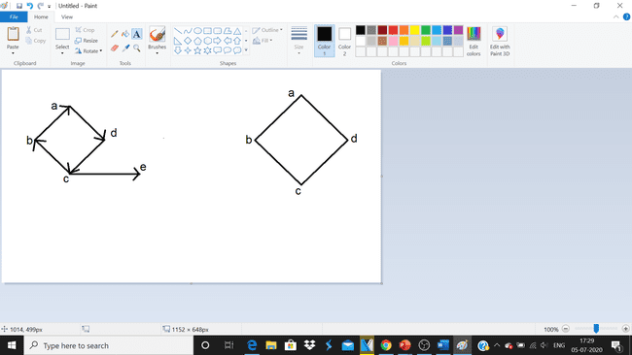

Hamiltonian cycle : a-b-c-d-a

Hamiltonian Path: a-d-c-b

1. If m = 20 and n= 9 , then what is the circuit rank for this graph?

Answer: The circuit rank for this graph is:

=m-(n-1)

=20-(9-1)

=20-(8)

=12.

The number of edges you need to delete from the graph in order to get a spanning tree **=** m-(n-1),which is called the circuit rank of the graph. This formula is true, because in a spanning tree you need to have ‘n-1’ edges.

Example: The given graph has n=5 vertices and m=7 edges. So;

= m-(n-1)

=7-(5-1)

=7-(4)

=3

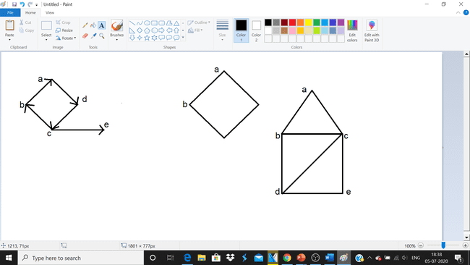

Out of ‘m’ edges, you need to keep ‘n–1’ edges in the graph. Hence, deleting ‘n–1’ edges from ‘m’ gives the edges to be removed from the graph in order to get a spanning tree, which should not form a cycle.

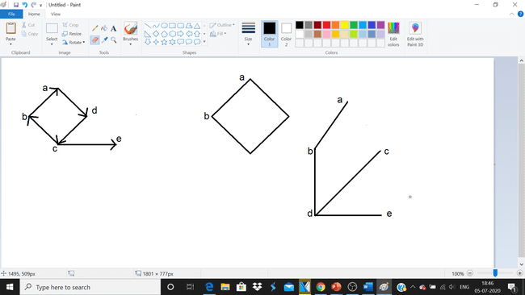

1. For the following graph build a spanning tree and also calculates its circuit rank. Use both the methods to build a spanning tree.

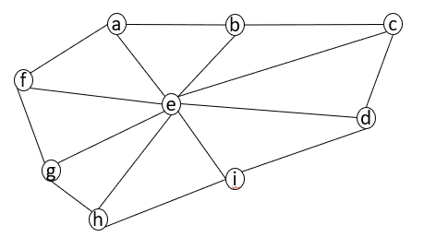

‘A’

Answer: Let the name of above graph be ‘A’ Let A be a connected graph, then the sub-graph B of A is called a spanning tree of A if −1)B is a tree 2) B contains all vertices of A .A spanning tree T of an undirected graph A is a subgraph that includes all of the vertices of A. So in the above graph, A is a connected graph and B is a sub-graph of A.

Clearly, the graph B has no cycles, it is a tree with edges which is one less than the total number of vertices.

Hence B is the Spanning tree of A.



‘B’

There are two methods:

* 1. CUTTING DOWN

Start choosing any cycle in A. Remove one of cycle's edges. Repeat this procedure until there are no cycle left. So; suppose we remove the edge ae,fe,ge,he,ie,cb,ce which destroy the cycle abcdihgfae and many more such cycles in the above graph and thus obtained the following spanning tree.



b.BUILDING UP:

Select edges of A one at a time. in such a way that no cycles are created. Repeat this procedure until all vertices are included. So; choose edge ae,be,ce,de,ie,he,ge,fe,af.



Finally, we obtain the above spanning tree.

The given graph has n=9 vertices and m=8 edges.

The circuit rank for this graph is:

=m-(n-1)

=8-(9-1)

=8-(8)

=0.

1. If a graph with 18 vertices is a regular bipartite graph then how many numbers of edges will make it a regular complete bipartite graph? Justify your answer appropriately and with a diagram.

Answer: The total number of edges is m*n .i.e m= number of vertices in set 1 and n is number of vertices in set 2. So; 9 vertices in each set that is m*n will be 9*9 = 81. So the total number of edges is 81.